ENGINEER OS · Computer Organization & Architecture
Chapter 02
Memory Fundamentals
Difficulty | Reading Time | Prerequisites | Learning Outcome
⭐ Beginner | 15–20 min | Chapter 01 | Explain RAM, memory addresses, the memory layout of a process, and Stack vs Heap — confidently, from first principles.

Learning Objectives
- Explain why memory exists at all, and why the CPU cannot execute a program directly from an SSD.
- Describe RAM as a grid of numbered memory cells, and explain what a memory address is.
- Draw and explain the memory layout of a running process: Code, Data, Heap, and Stack.
- Explain what a stack frame contains, and why deep recursion causes a Stack Overflow.
- Compare Stack and Heap memory, and know when each is used.

Story
📖 The Library & The Desk
A library (SSD) stores every book permanently, but you can't write in them, and searching every shelf takes time. So you carry a few books to your study desk (RAM) to work quickly. The moment you leave the room, your desk is cleared — anything you didn't copy back into a book is gone forever.

Visual Imagination

Data must move closer to the CPU to be used — SSD is simply too slow for direct execution.
Explain Like I'm Five
🧠 The Small Desk
You can't pile every book from the library onto your desk — it's too small. RAM is that small, fast desk. The SSD is the giant, slow library down the hall. The CPU only ever works from the desk, never the library shelves directly.

First Principles — Why Memory Exists
- The CPU needs data in nanoseconds to keep executing instructions without stopping.
- SSDs (and hard disks) are electrically and mechanically far too slow to supply data at that speed.
- So computers use a middle layer — RAM — that is much faster than SSD, sitting physically and electrically closer to the CPU.
- Memory, in short, exists to bridge the enormous speed gap between permanent storage and the CPU.

RAM, Memory Cells & Addresses
Simple Engineering Explanation
RAM (Random Access Memory) is the computer's fast working memory. It is organized into millions of tiny storage units called memory cells. Each cell holds exactly one byte (8 bits), and each cell has its own unique memory address — a number the CPU uses to find it instantly, in any order (hence “random access”).
Diagram — RAM as a Grid of Cells
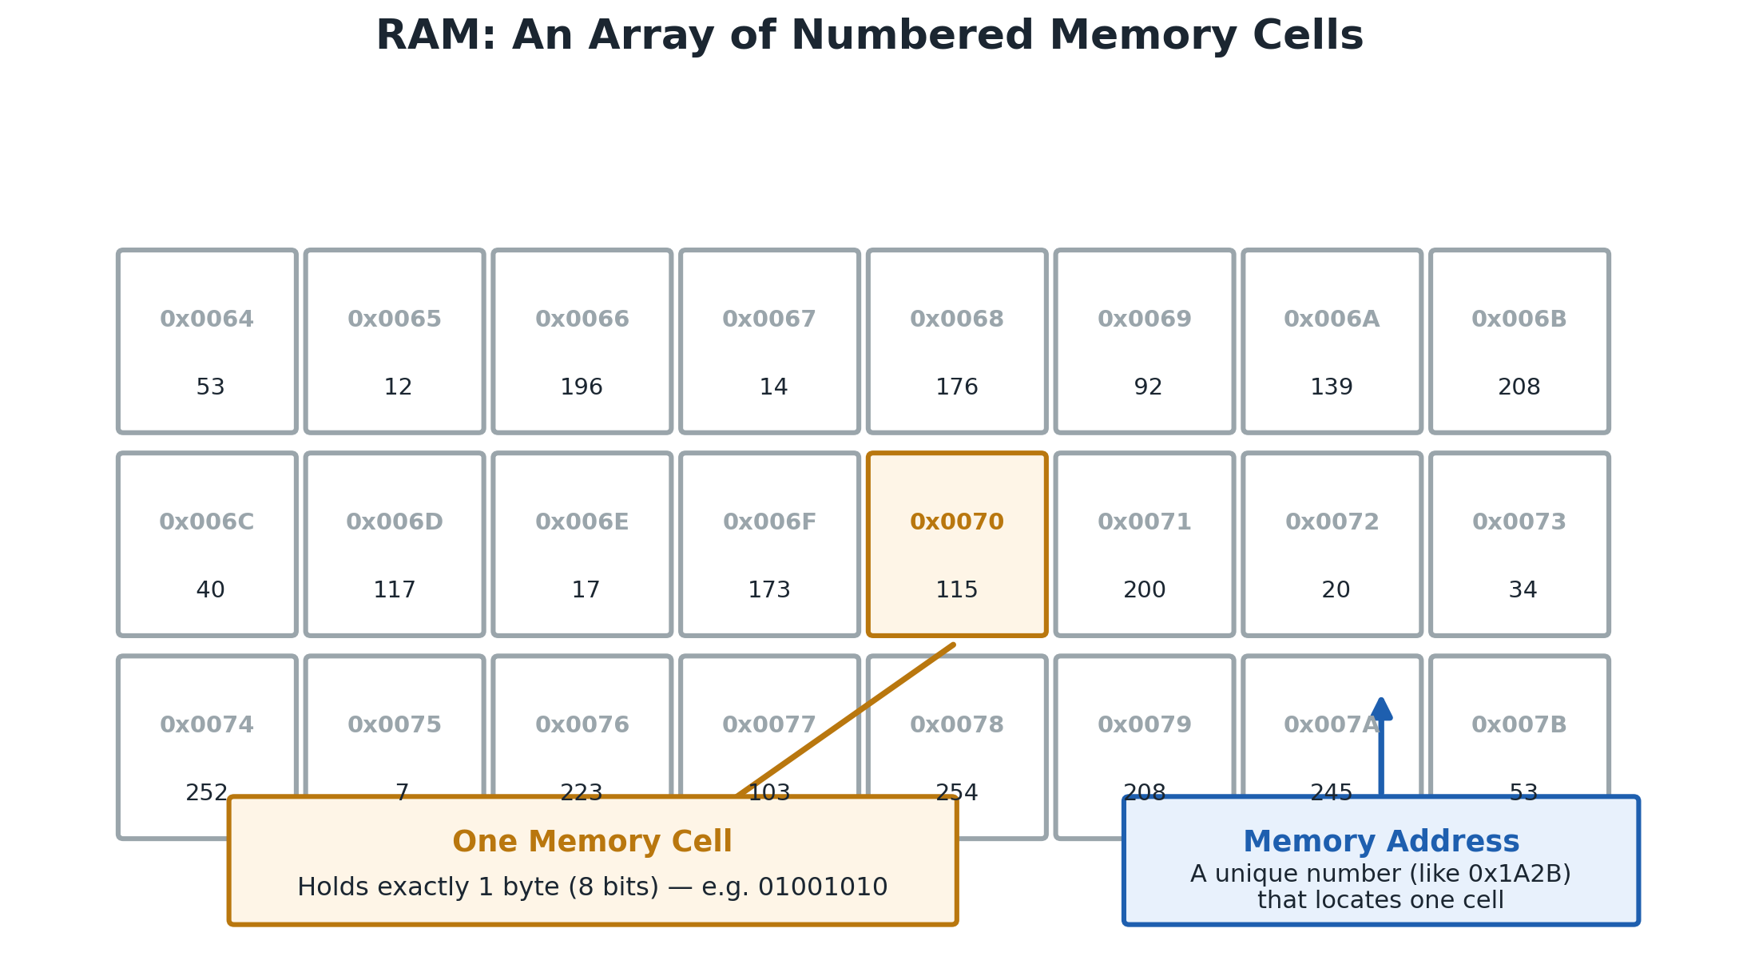
Every cell has an address (e.g. 0x1A2C) and stores one byte of data.
Diagram — How the CPU Reads an Address
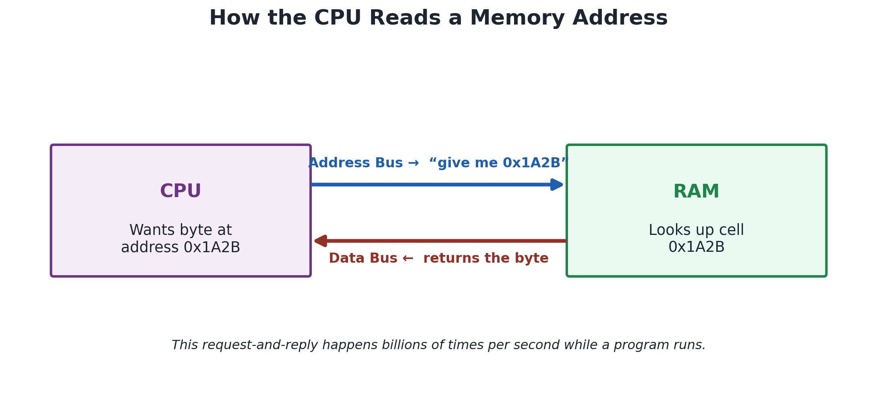
The CPU sends an address on the address bus; RAM replies with the value on the data bus.
💡 Engineer Note
Because the CPU can jump straight to any address (instead of reading in order, like a cassette tape), RAM access is called “random access” — this randomness is exactly what makes RAM so fast for running programs.

Volatile Memory
RAM is volatile: it needs a constant electrical current to hold its data. The instant power is cut — shutdown, crash, or power outage — every value stored in RAM disappears immediately. This is precisely why unsaved work is lost when a program crashes: it existed only in volatile RAM, and never made it back to permanent storage (SSD).
⚠ Common Mistake
“RAM stores my files permanently.” Reality: RAM only holds data while the program is running and power is on. Files are only safe once written to non-volatile storage like an SSD.

Memory Layout of a Process
When the Operating System runs your program, it gives it a private slice of address space divided into clear regions. Each region has a specific job — together they hold everything a running program needs.
Diagram — The Full Memory Layout
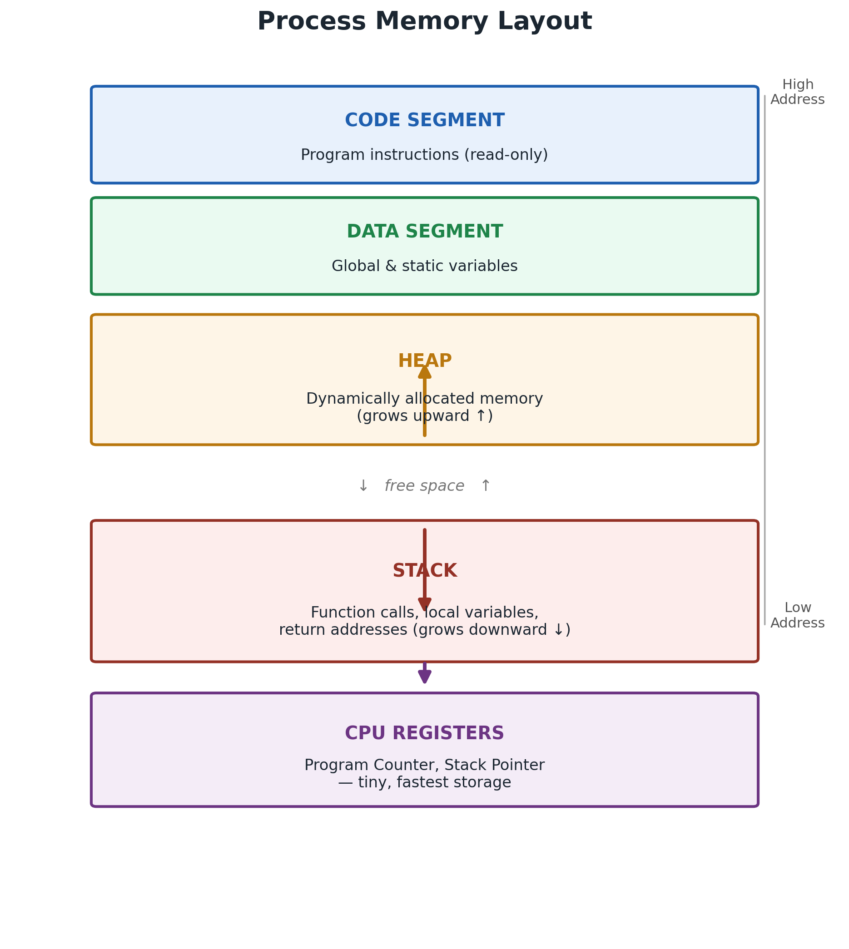
From top (high addresses) to bottom (low addresses): Code, Data, Heap, Stack, and Registers.
Each Region, Explained
Code Segment — Holds the compiled machine instructions of your program. It is read-only — a program should never modify its own instructions while running.
Data Segment — Holds global variables and static variables — values that exist for the entire life of the program.
Heap — Holds memory you request dynamically at run time (e.g. via malloc() or new). It grows upward as you allocate more, and must be freed manually or by a garbage collector.
Stack — Holds function call information: local variables, parameters, and return addresses. It grows downward automatically, and shrinks the moment a function returns.

🚀 Real World
Every app you open — a browser, a game, VS Code — gets this exact same layout from the OS. Understanding it is the foundation for debugging crashes, memory leaks, and security vulnerabilities like buffer overflows.

Stack Frames, Overflow & Stack vs Heap
The Stack Is LIFO
Every time a function is called, a new stack frame is pushed on top of the stack. When that function returns, its frame is popped off. This Last-In-First-Out (LIFO) discipline means the most recently called function always finishes first — just like a stack of plates.
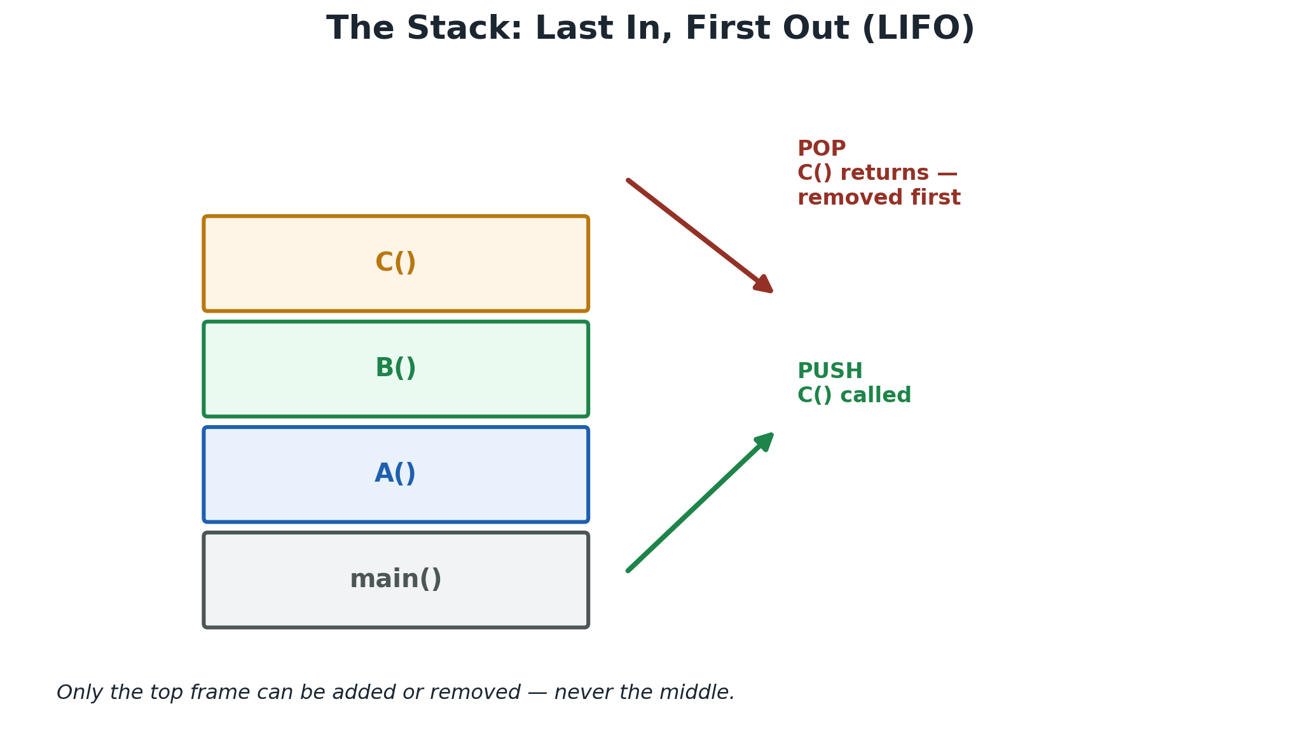
PUSH adds a new frame on top when a function is called; POP removes it when the function returns.
Inside a Stack Frame
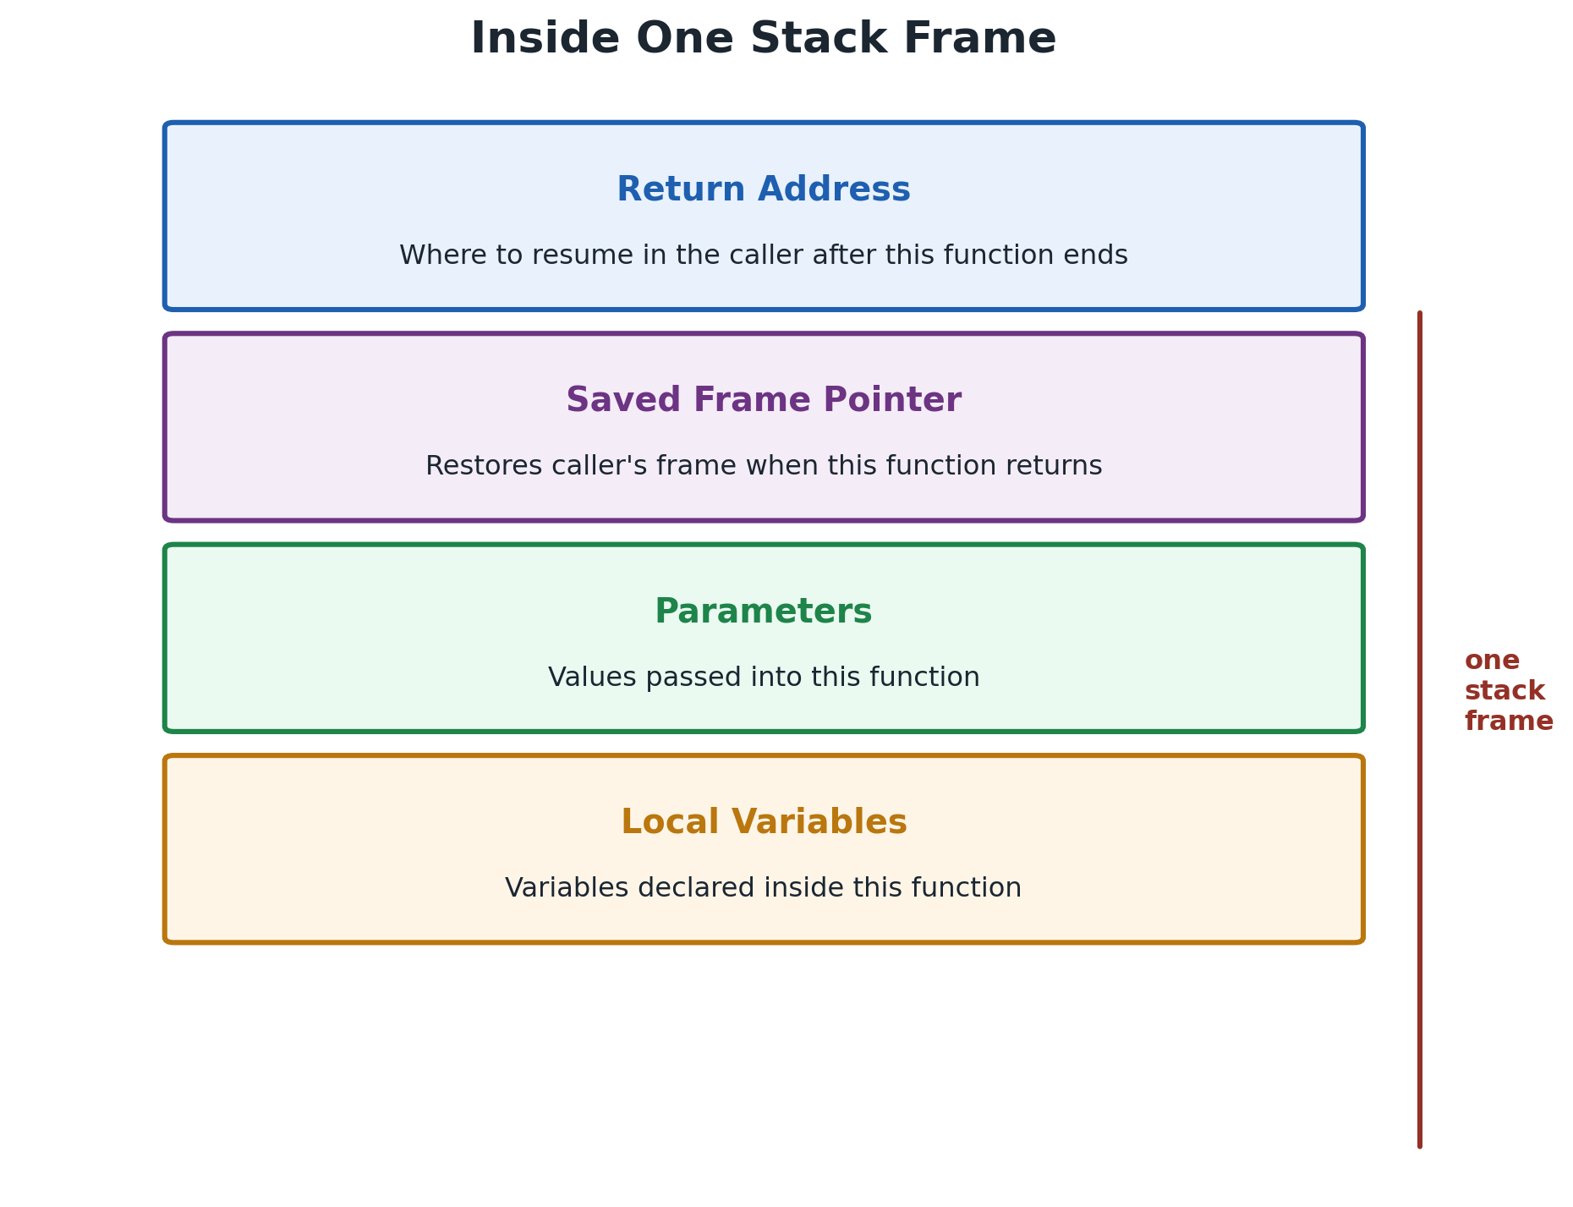
Each call gets its own frame holding the return address, saved frame pointer, parameters, and local variables.
Stack Overflow
A Stack Overflow happens when a program pushes more frames than the stack's fixed size can hold — most commonly caused by infinite or excessively deep recursion. When the limit is hit, the Operating System immediately terminates the program to protect other memory.
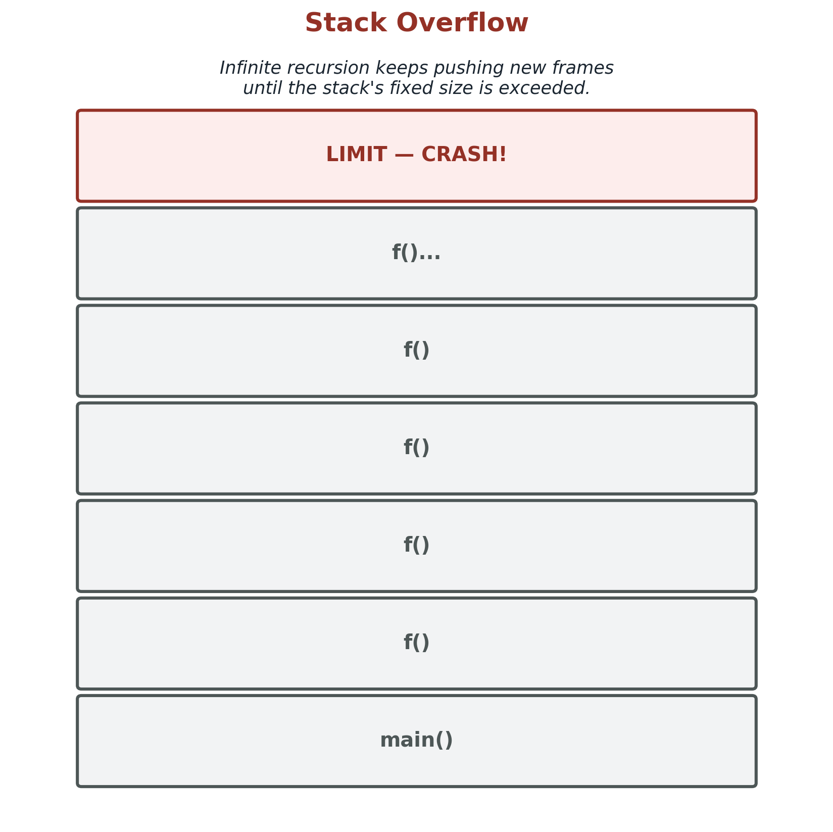
Each recursive call adds another frame until the stack's boundary is exceeded and the program crashes.
🎯 Interview Tip
If asked “why does deep recursion crash?” always mention: (1) the stack has a fixed, limited size, and (2) every call — even without much data — still consumes space for its return address and frame pointer.

The Heap
Unlike the stack, heap memory is not automatically managed by function calls. You (or a runtime's garbage collector) explicitly allocate it when needed and free it when done. This flexibility comes at a cost: heap access is slower than stack access, and forgetting to free memory causes a memory leak.
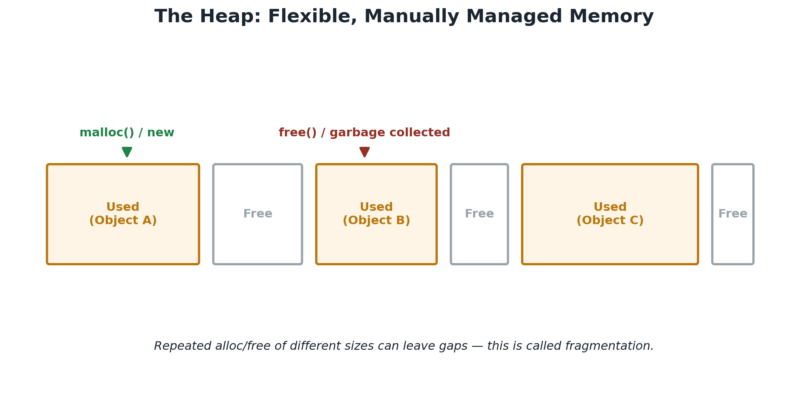
Used and free blocks sit side by side on the heap; repeated allocation/free cycles can fragment it.
Stack vs Heap — Visual Comparison
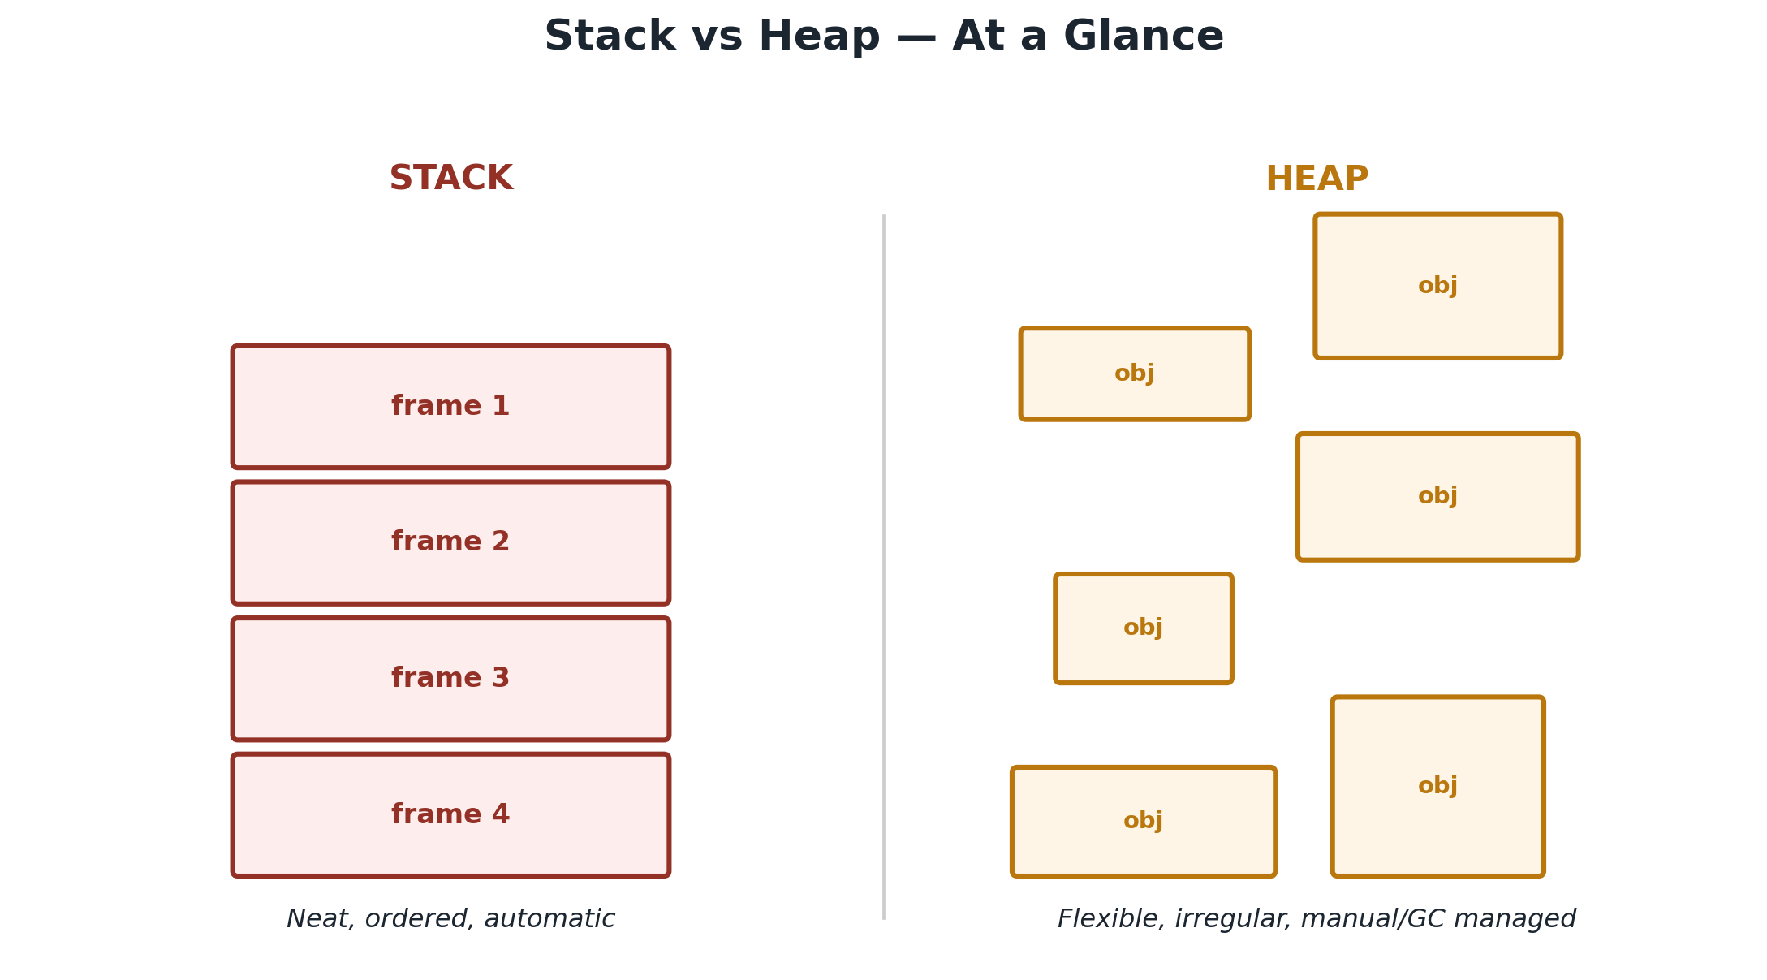
Stack: neat, ordered, automatic. Heap: flexible, irregular, manually or GC-managed.
Stack vs Heap — Comparison Table
Aspect | Stack | Heap
Managed by | CPU / compiler, automatic | Programmer / garbage collector
Speed | Very fast | Slower (extra bookkeeping)
Size | Small, fixed limit | Large, flexible
Lifetime | Freed when function returns | Lives until explicitly freed / collected
Common risk | Stack Overflow (deep recursion) | Memory leak (never freed) or fragmentation

🧠 Memory Trick
Stack = Simple, Sequential, Small, Self-cleaning. Heap = Huge, Handled-by-you (or GC), Hesitant to clean itself.

Interview Prep, Revision & Practice
Interview Corner — Top 5
Q. What is the difference between Stack and Heap?
A. Stack is automatic, fast, fixed-size memory for function calls & locals. Heap is flexible, manually/GC-managed memory for dynamic objects.
Q. Why does a Stack Overflow happen?
A. Too many nested function calls (e.g. infinite recursion) exceed the stack's fixed size, so the OS terminates the program.
Q. Why can't the CPU execute directly from SSD?
A. SSD is far too slow and not designed for instant, byte-level random access at CPU speed; data must be copied into RAM first.
Q. What is volatile memory?
A. Memory that loses all its data the moment power is removed — RAM and CPU registers are both volatile.
Q. What is a memory address / memory cell?
A. RAM is divided into numbered cells, each storing one byte; the address is the unique number identifying a specific cell.
Quick Revision
💡 Remember
SSD (permanent) → RAM (volatile, fast) → CPU Registers (fastest). A process's memory = Code + Data + Heap + Stack.

🎯 Golden Rule
RAM remembers only while it has power. The Stack is automatic but limited; the Heap is flexible but must be managed.

Flashcards
Q: What does a stack frame hold?
A: The return address, saved frame pointer, parameters, and local variables.

Q: What happens to RAM when power is lost?
A: All data is erased instantly — RAM is volatile.

Q: Which memory region holds dynamically allocated objects?
A: The Heap.

Q: What usually causes a Stack Overflow?
A: Deep or infinite recursion exceeding the stack's fixed size.

Mini Quiz
1. Which memory type loses its data when powered off? (a) SSD (b) RAM (c) Hard Disk
2. A function call creates a new: (a) Heap block (b) Stack frame (c) Register
3. A unique numbered RAM location is called a: (a) Memory address (b) Cache line (c) Bytecode
Short Answer: Why is heap memory riskier to manage than stack memory?
Short Answer: In 2–3 lines, explain why the CPU can't execute a program directly from SSD.

Next Chapter
🚀 Coming Up — Chapter 03: What Is a CPU?
We've seen where data lives. Next, we open up the CPU itself: registers, the ALU, the control unit, and how billions of Fetch-Decode-Execute cycles happen every single second.

End of Chapter 02 — Engineer OS: Computer Science Core

